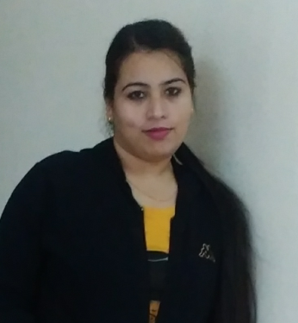

**Curriculum vitae**

**Manpreet Kaur Saini**

# 132 A First Floor Gautam Nagar,

New Delhi 110049

Mobile no. 09821538835

e-mail id: **manpreetcandc@gmail.com**

**CAREER OBJECTIVE**

To seek a challenging position in an organization providing a good environment where I can effectively utilize my knowledge and talent for the organizational and individual development and to gain recognition as a successful professional by being an asset to the organization and the society.

**ORGANIZATIONAL EXPERIENCE**

**Since January 2011 to October 2016 at C & C Towers Ltd. Chandigarh**

Designation: Executive Assistant to Chief General Manager (CGM)

Job profile**:**

* Travel arrangements to be made as per CGM's programs. Booking of flight Tickets, Hotel Accommodations, Boarding & Lodging, and Cabs to be arranged in advance to Director's travel.
* Secrecy to be maintained on Confidential matters of the organization.
* Maintain good relationship with all other Colleagues of the organization.
* Handle all Secretarial works independently as per CGM's Advice.
* Arrangement of Meetings as per CGM's Schedules / availability.
* Handling Business Correspondence via emails.
* Preparing Power Point presentation.
* Updating Master Database - corporate contacts.
* Travel Arrangement and guest arrangments.
* Client coordination.
* Preparation of travelling expense reports (Domestic and International travels).
* Updating Telephone List, Service providers list and all related vendors.
* Preparation of miscellaneous expense reports
* Tohandle Customer relationship (CRM)

**Since July 2008- November 2010 ADVS Combines**

Designation – Manager

Job Profile**:**

* Worked as a event coordinator.
* Handled Telephonic and Electronic Department of Admissions.
* To handle the queries and management of team of 20 members.
* Counselling & To solve the queries.
* Arranged the functions and events.

**ACADEMIC CREDENTIALS**

Graduation in arts from Panjab university 2004- 2007.

Radio jockey course from Academy of Broadcasting Chandigarh.

German language course A2 Level from Goethe institute from Delhi.

**EXTRACURRICULAR ACTIVITIES**

• Handled promotions for clients like DLF in IPL in 2008

• Handled sports activities for the state of Chandigarh.

• Awarded with the title “Best in sports” for the year 2007 in G. G. C.W. Sec – 26 Chandigarh.

• Participated National games, 2006 In Bhilai. And participated in inter university sports tournaments at Kuppam university in M.P.

**COMPUTER PROFICIENCY**

Operating Systems: Windows 95, 98, 2000, XP, Vista, 7

Package: Microsoft Office 2003 & 2007, Microsoft Office Power Point, Adobe photo-shop.

**PERSONAL SNAPSHOT**

* Excellent communication skills, Confident, Quick Learner and honest.
* Always keep the interest for learning new things.

**Hobbies / Interests**

Driving, Talking with people and composing.

**PERSONAL DETAILS**

Marital Status – Married

Spouse Name – RajinderSingh

Sex - Female

Date of Birth- 2 Dec, 1986

Language Known- Hindi, English, Punjabi and German.

Manpreet Kaur